San Jose State University

Department of Electrical Engineering

EE250-03
Fall 2017

Final Examination

Duration: 2 hours

SOLUTION

December 14, 2017

This test consists of five problems.

OPEN BOOK
Use of books, notes, or any other material is allowed.

Last Name:

First Name:

Student ID:

Problem | Grade
1
2
3
4
5

Total

Good Luck!

Prof. Kamali

Problem #1 [8 points]: Supposeis a uniform random variable between 0 and 1. Find the pdf of 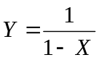 .

Solution:
First we note that

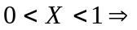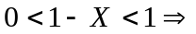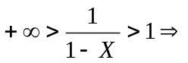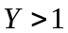

Thus 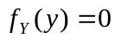for 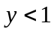.

For 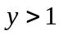,

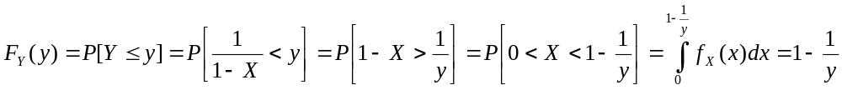
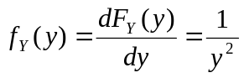

Problem #2 [9 points]: The joint pdf of random pair  is given as follows.

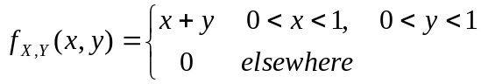

Find 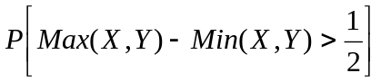.

Hint: Find the region in the plane where 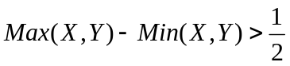.

Solution:
If 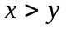, then 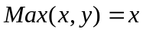 and 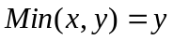. Thus 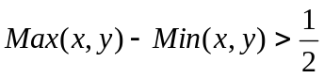will be 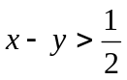 for (Area ). If 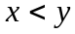, then 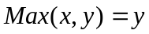 and 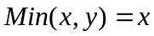. Thus will be 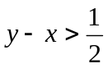 for 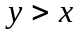 (Area ).
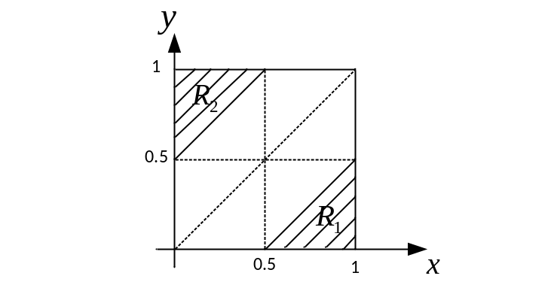
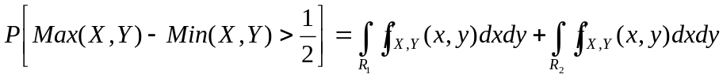

We note that changing to , will change to . Since 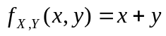 is symmetric respect to and , the above two integrals are equal.
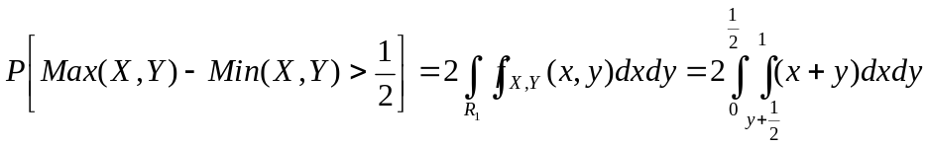
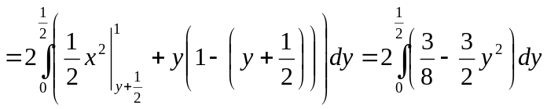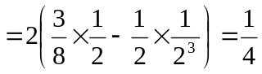
Problem #3 [9 points]: Consider the discrete-time random process 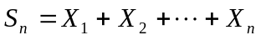 where 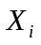's are iid with Bernoulli distribution (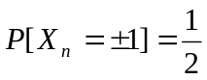). Find 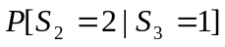.

Hint: 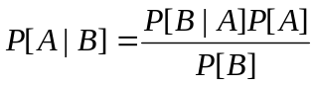

Solution:

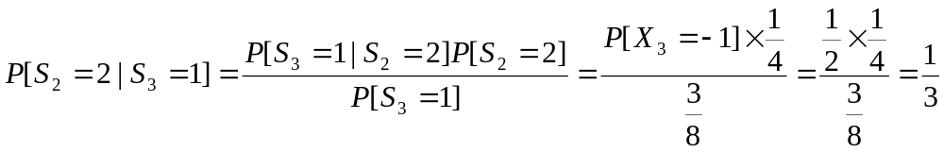

where we have used the following equations.

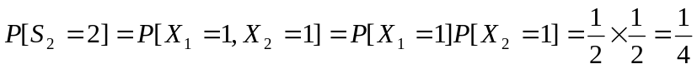

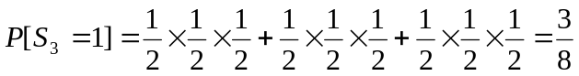

Problem #4 [8 points]: Consider the random process 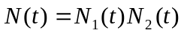 where 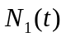and 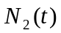 are two independent Poisson random processes with average rates of 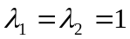.

- Does 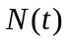have independent increment property?
- Find 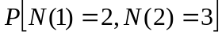.

Solution:
- Yes. We note that 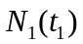is independent of 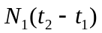due to the independent increment property of . Furthermore is independent of 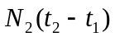because and are independent. Similarly 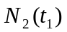is independent of both and . Thus the product of 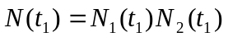will be independent of 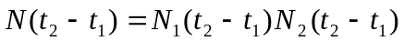 which proves that has independent increment property.

- Using the fact that has independent increment property, we have

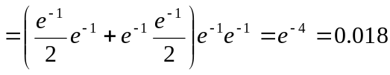

Problem #5 [6 points]: Suppose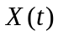is a zero-mean stationary random process with the auto-correlation function 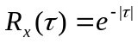. Find 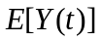 where 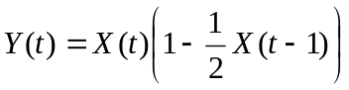.

Solution:

